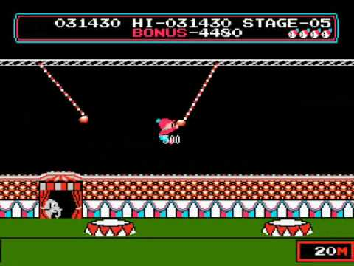

Hello Amy!

Edward is finally here! The final game of Orange Belt! This is a massive project and he has completed much of it today!

There's been a lot of new concepts, over a thousand lines of code and loads of fun games created and played to get up to here! Edward had to do a lot of this one himself just like the bug invaders game, the last one of yellow belt!

We firstly coded our trampoline to follow the mouse! The code uses the getPointerPos function, which will get the coordinate position of our mouse, to move the trampoline! The rest of our code was inside the Ninja to have him interact with our scene for the game! Firstly, Edward made the $this.speedX of the Ninja a random value between whatever numbers Edward chooses, to start off our Ninja moving from left to right.

We also coded the game to increase the falling speed of our ninja by the value of a gravity variable. If gravity was 4, then every frame the Y speed increases by 4! Edward also made the ninja spin in the air over time to look more realistic! Finally we moved onto making our ninja bounce! A simple isTouching function checking if we touch the trampoline. if it does, the vertical axis speed would be increased to make the ninja bounce back up! This way the Ninja moves along to the right, does loads of spinning somersaults and bounces off the trampoline!

This is great work so far but next lesson we need to add an objective to the game! There will be hoops to jump through and score to be lost if we miss the trampoline! Great work so far Edward! Keep it up!